File name | Image | Alt text
Sec 1_Email Invite | 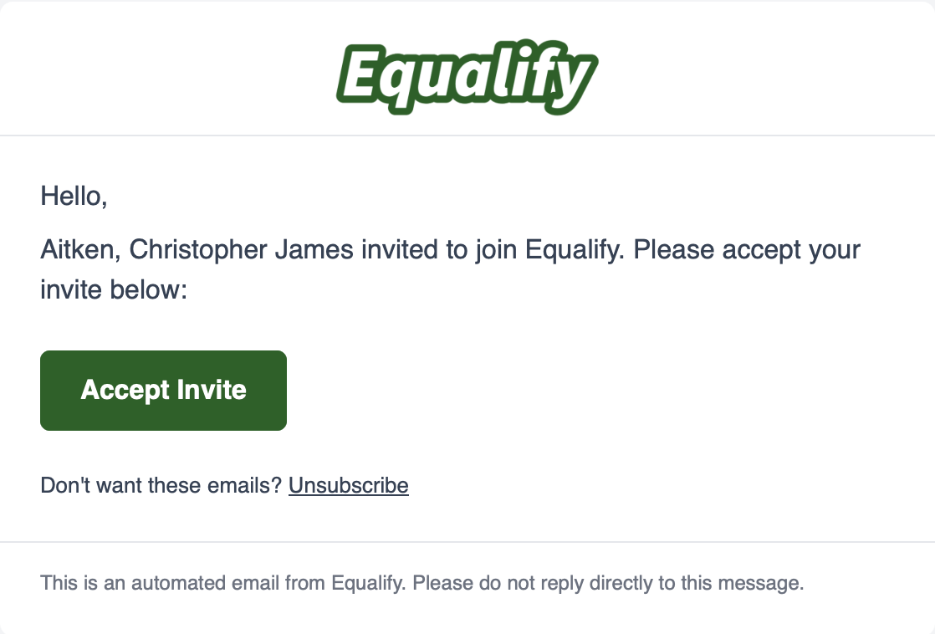 | Email invitation to join Equalify with a "Accept Invite" button and an Unsubscribe link.
Sec 1_Sign In | 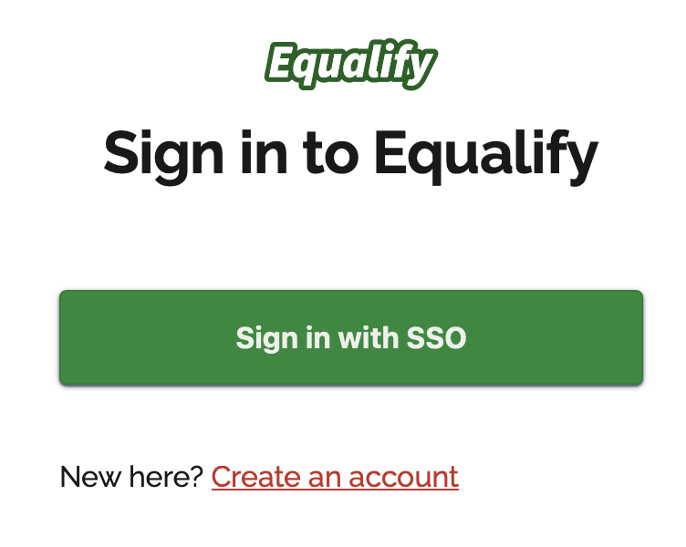 | Equalify sign-in page displaying the heading “Sign in to Equalify”, Sign in with SSO button, and a Create an account link for new users.
Sec 1_Sign Up | 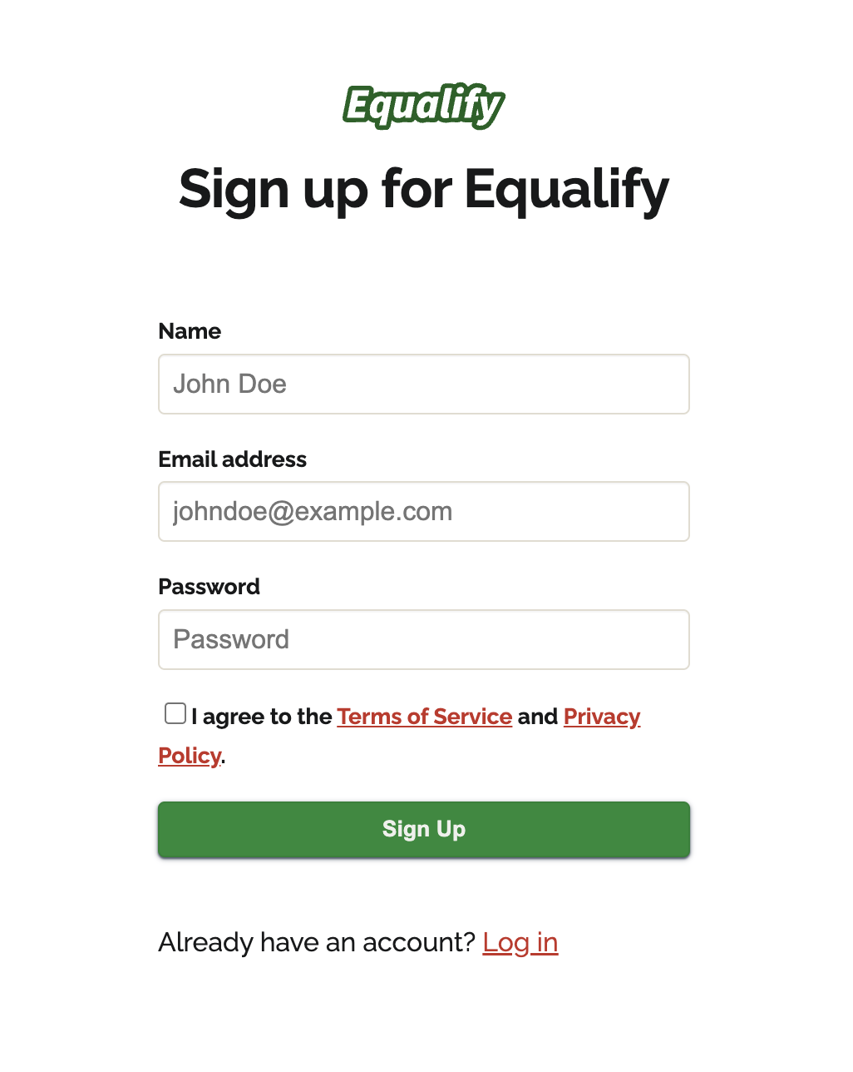 | Sign up page for Equalify with name, email address, and password fields, a Terms of Service and Privacy checkbox, a green Sign Up button, and a Log In link.
Sec 1_Waitlist | 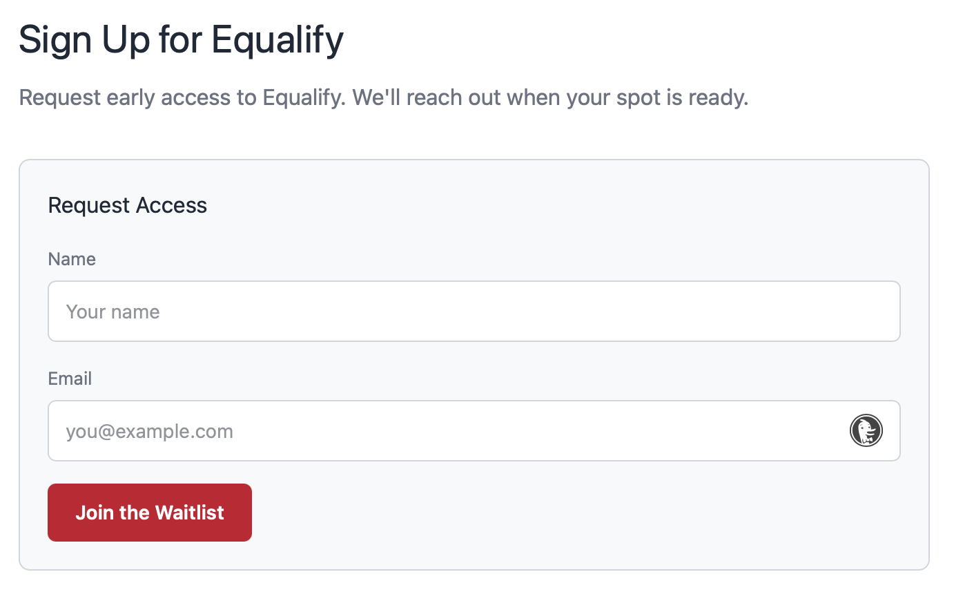 | Equalify early-access sign-up form titled “Sign Up for Equalify” with Name and Email fields and a Join the Waitlist button.
Sec 2_Add URLs Manual | 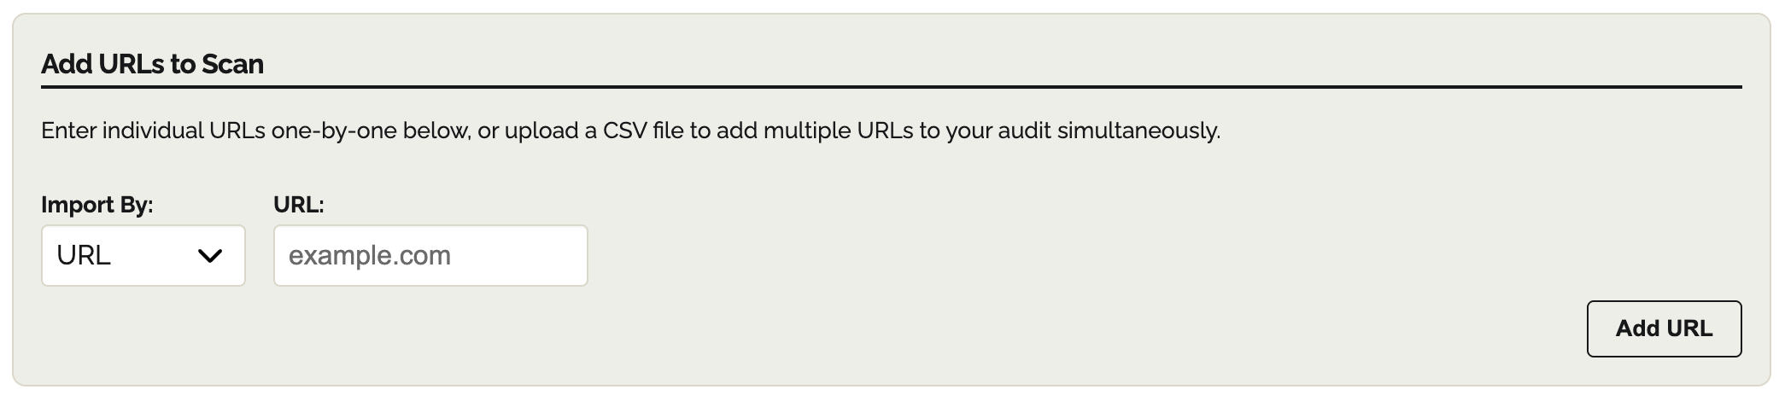 | Add URLs to Scan with Import By dropdown set to URL, a URL text input with placeholder “example.com,” and an Add URL button.
Sec 2_All Audits | 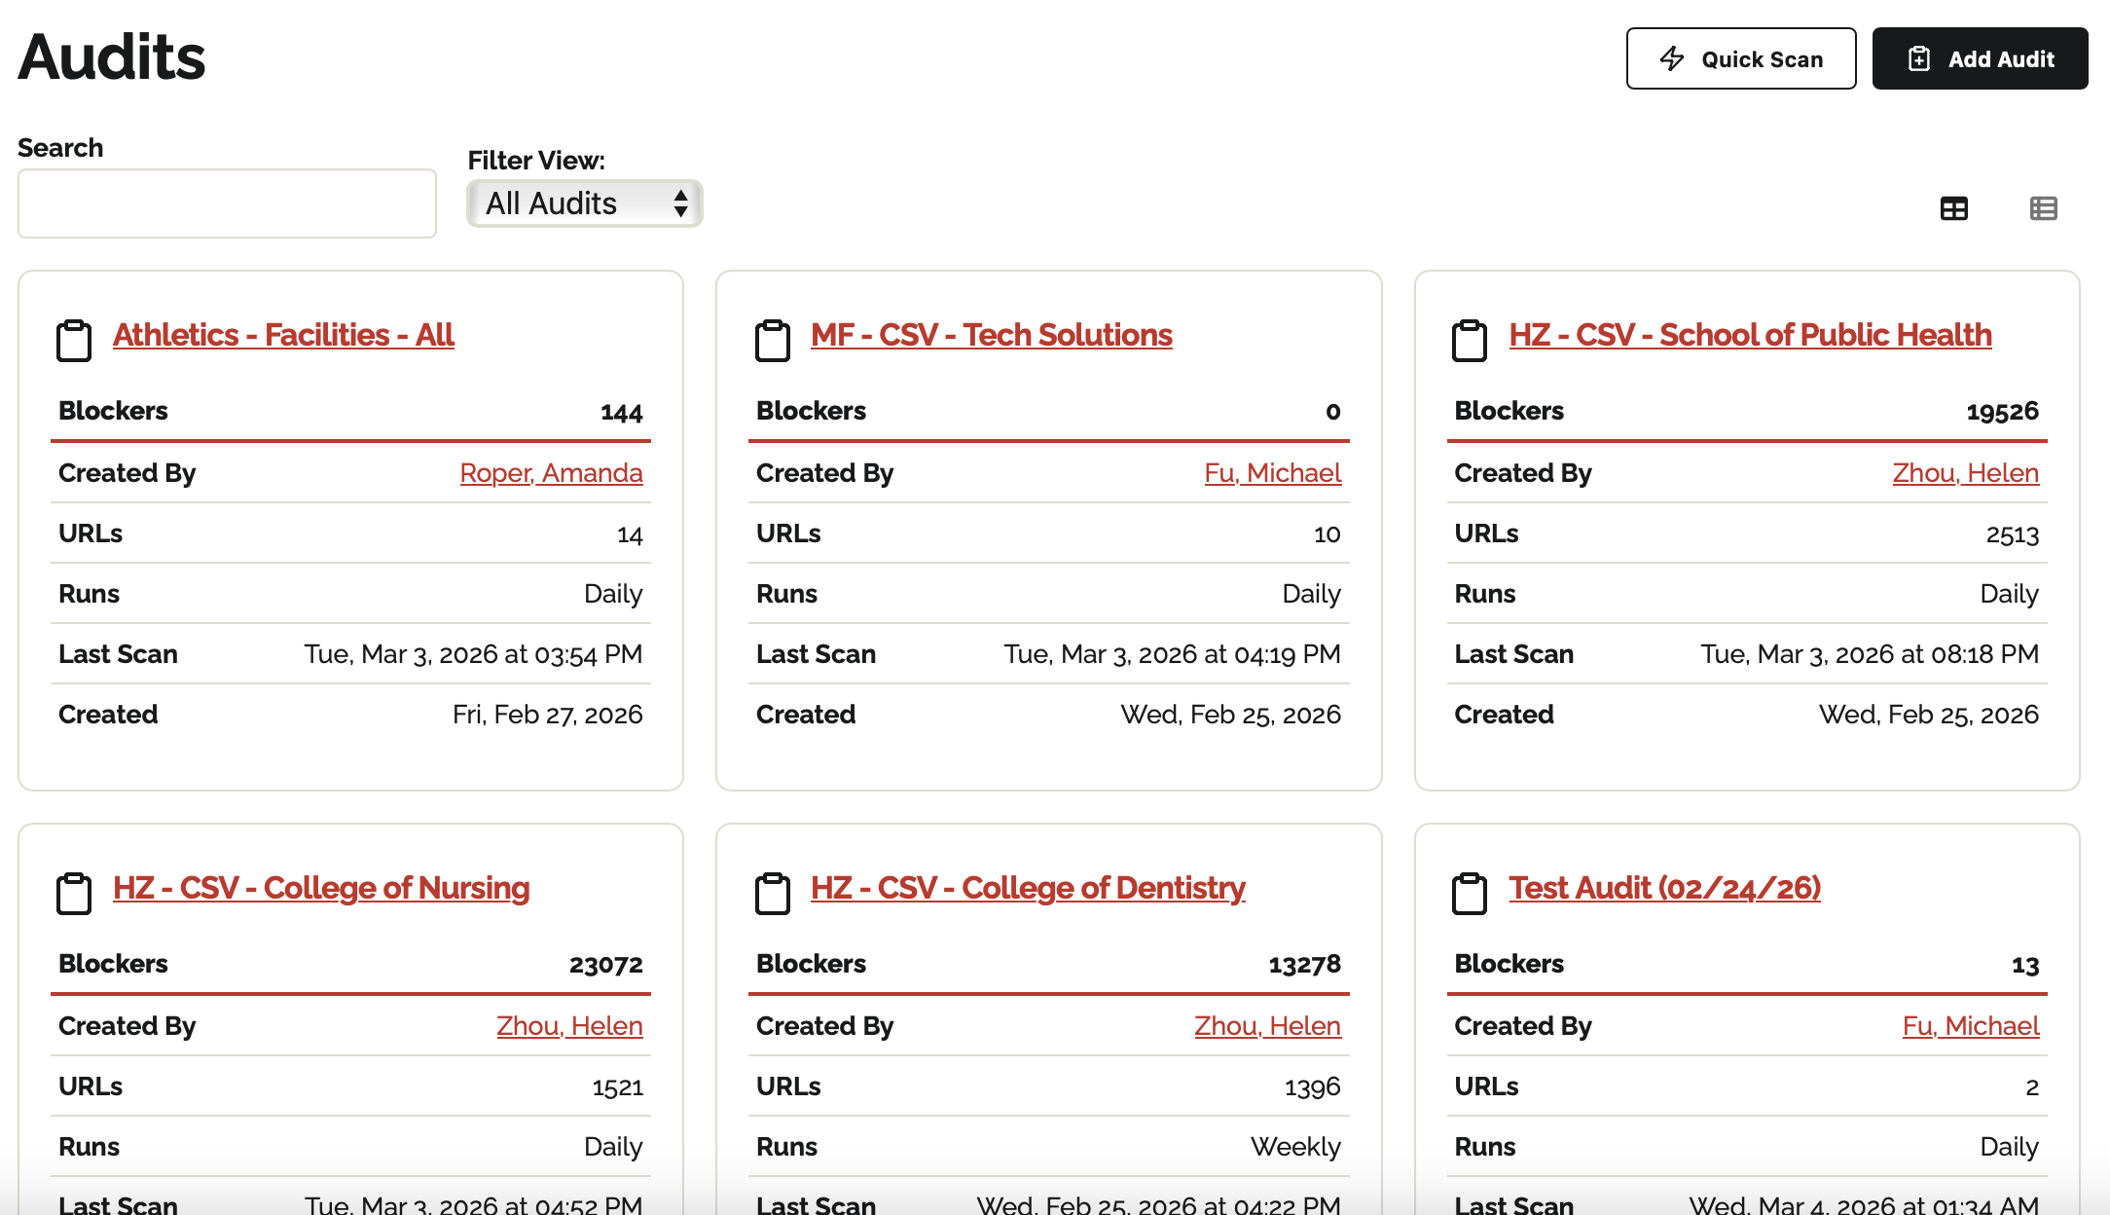 | The "Audits" page showing multiple project cards, such as Athletics, Tech Solutions, and various Colleges. Each card displays the number of accessibility blockers, the creator's name, the number of URLs scanned, and the date of the last scan. The "Filter View" is set to "All Audits".
Sec 2_Audit Builder Frequency | 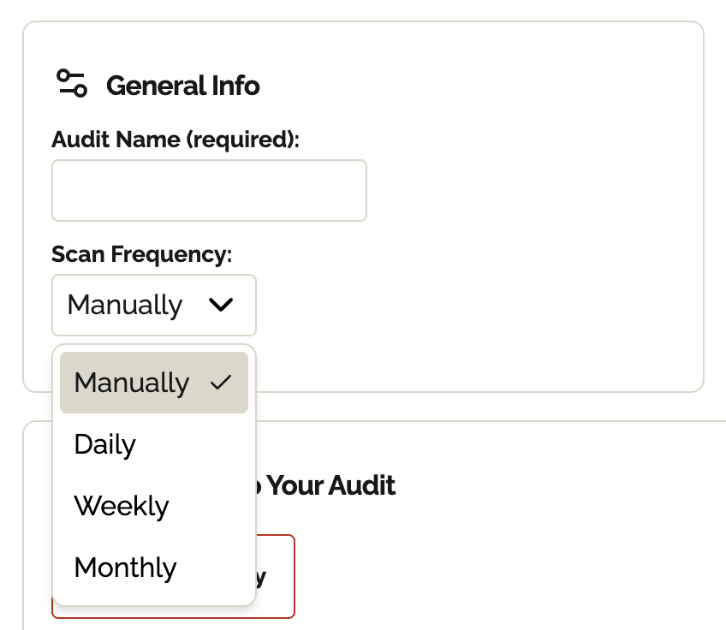 | General Info section with Audit Name (required) text field and Scan Frequency dropdown set to Manually.
Sec 2_Audit Builder Name | 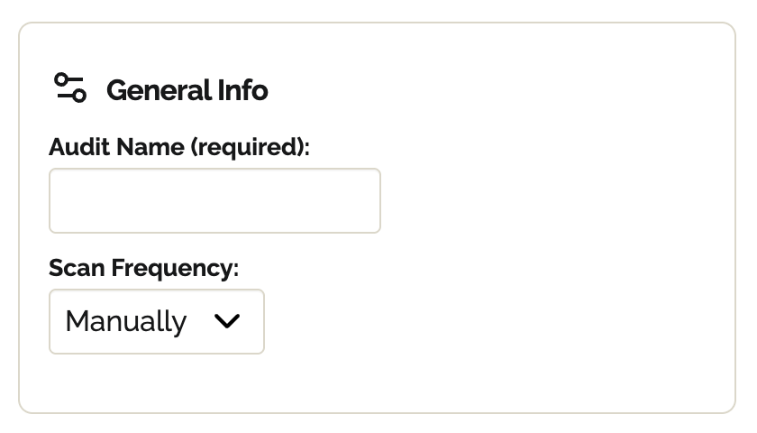 | General Info configuration panel displaying Audit Name (required) input field and Scan Frequency dropdown selector.
Sec 2_Audit Dashboard | 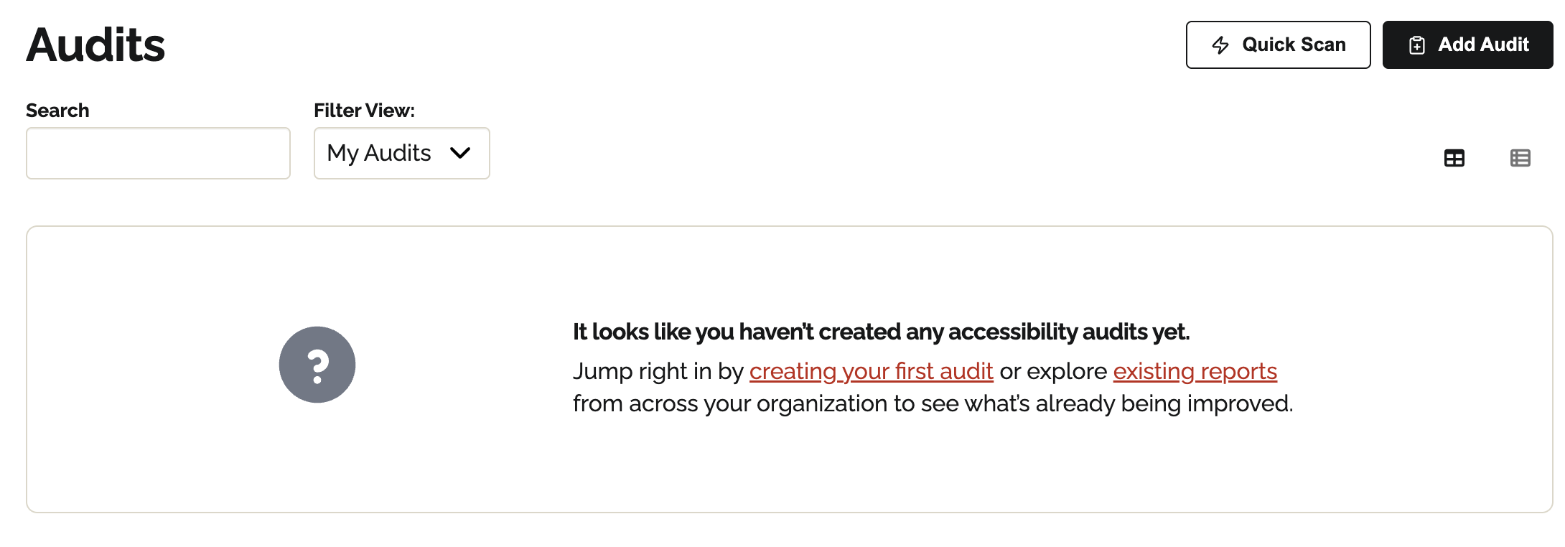 | Audits dashboard with Search field, Filter View: My Audits dropdown, and buttons Quick Scan and Add Audit, plus a message stating no accessibility audits have been created yet.
Sec 2_Duplicate Upload | 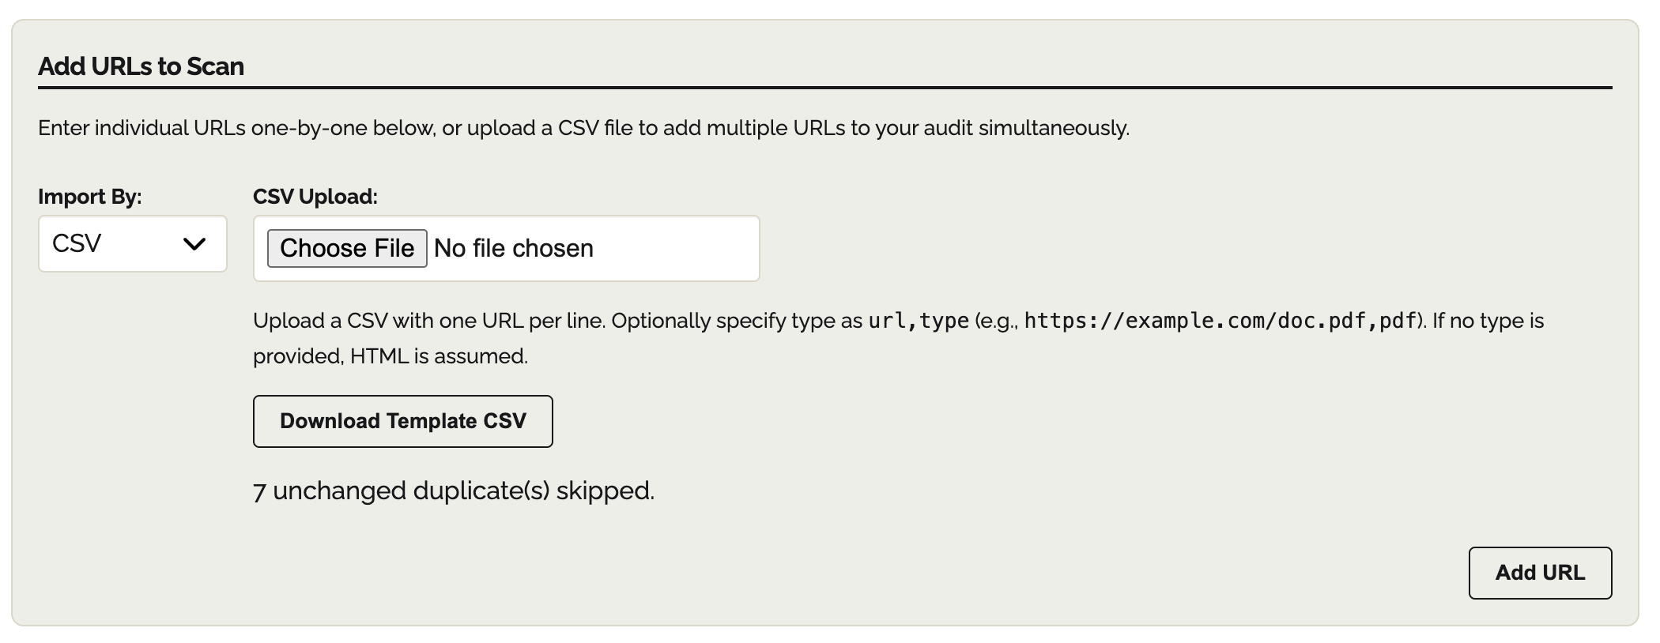 | CSV upload panel showing message “7 unchanged duplicate(s) skipped” under CSV upload instructions and Download Template CSV and Add URL button.
Sec 2_In-Progress audit | 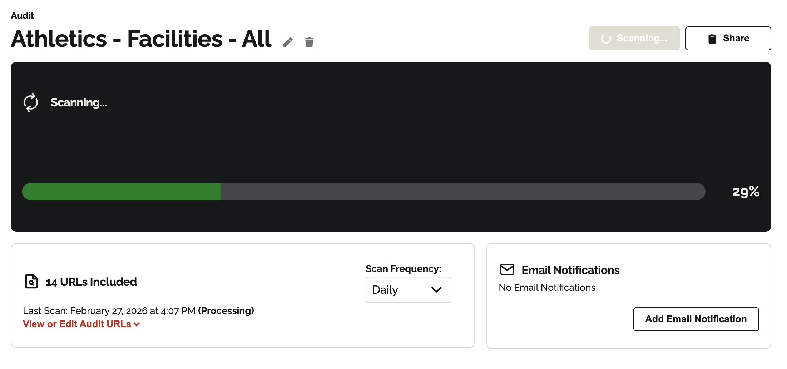 | Audit page titled “Athletics – Facilities – All” displaying Scanning… status and a progress bar showing 29% completion.
Sec 2_My Audits | 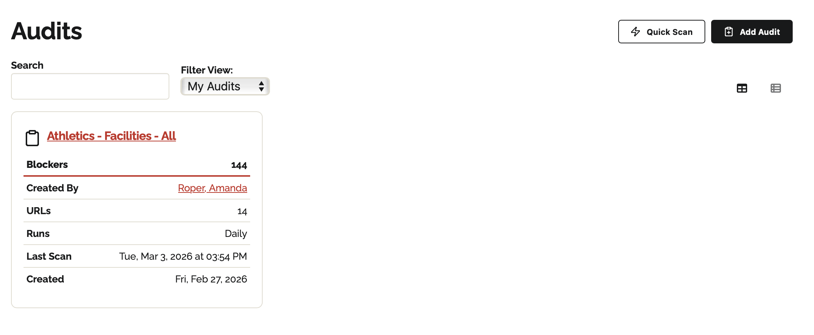 | The "Audits" dashboard with the "Filter View" set to "My Audits". Only one audit card, titled "Athletics - Facilities - All," is visible, showing 144 blockers across 14 URLs.
Sec 2_Removing URLs from Dashboard | 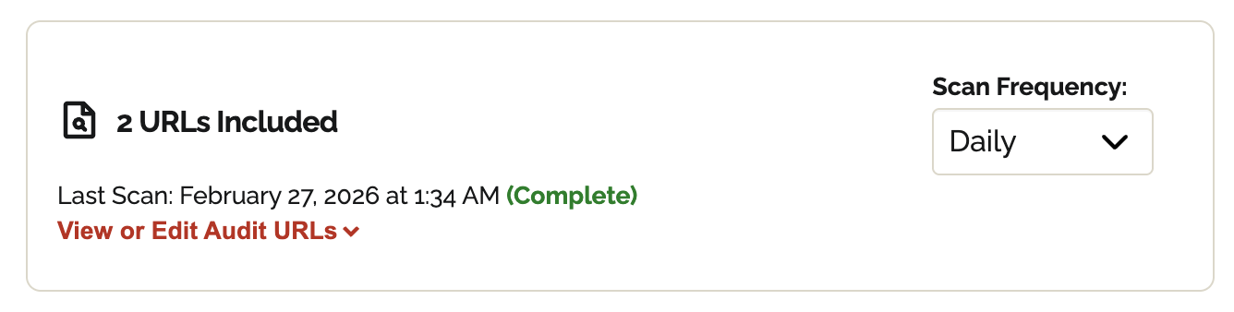 | URL list table noting 2 URLs included with a “View or Edit Audit URLs” dropdown.
Sec 2_Removing URLs | 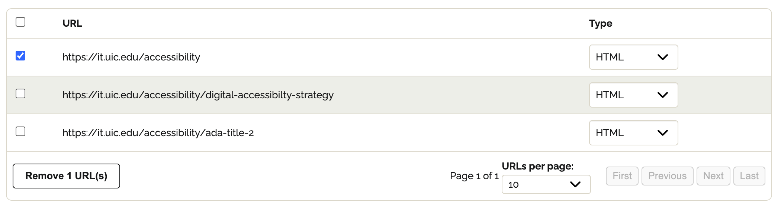 | URL management table listing multiple URLs with Type dropdowns (HTML or PDF) and selectable checkboxes for removal. One is selected and a Remove 1 URL(s) button below the list.
Sec 2_Save and Run Audit options | 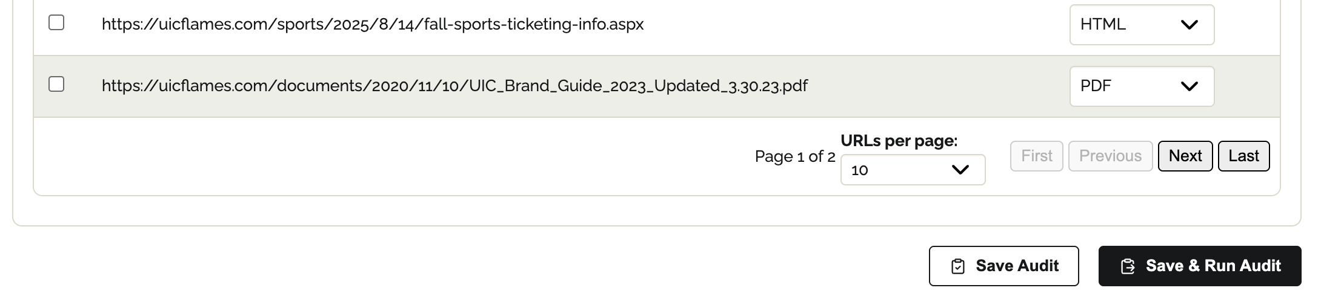 | Audit builder showing Save Audit and Save & Run Audit buttons alongside pagination and URLs per page controls.
Sec 2_Saved audit draft | 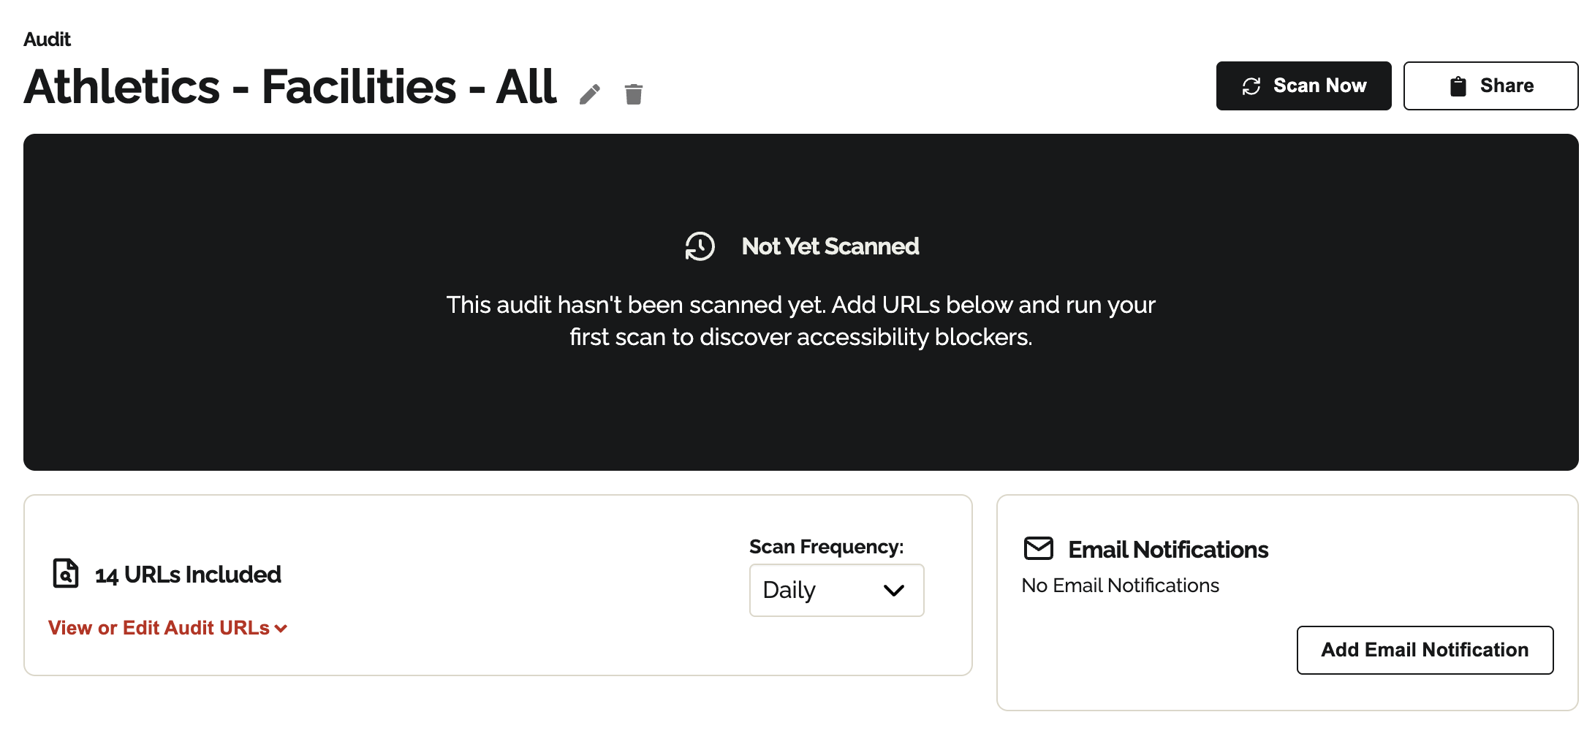 | Audit summary card draft displaying the message Not yet Scanned. This audit hasn’t been scanned yet. Add URLs below and run your first scan to discover accessibility blockers.
Sec 2_Successful Upload | 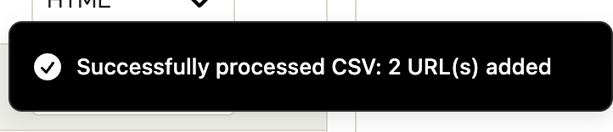 | Confirmation notification banner stating “Successfully processed CSV: 2 URL(s) added”.
Sec 2_WordPress CSV Export | 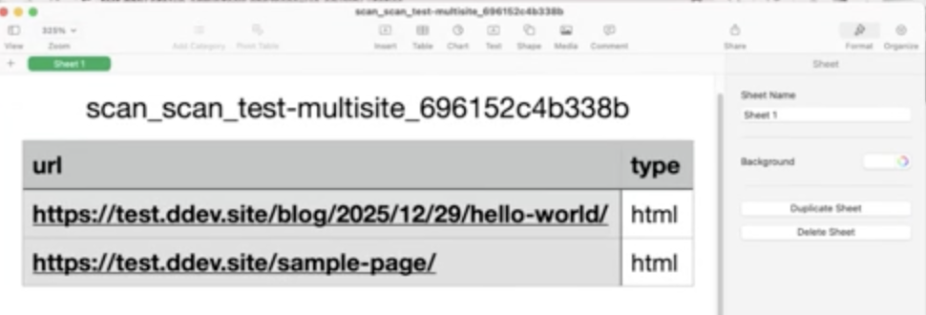 | CSV sample file export with scan title at the top and URL and Type columns.
Sec 2_WordPress UIC + Equalify Utilities | 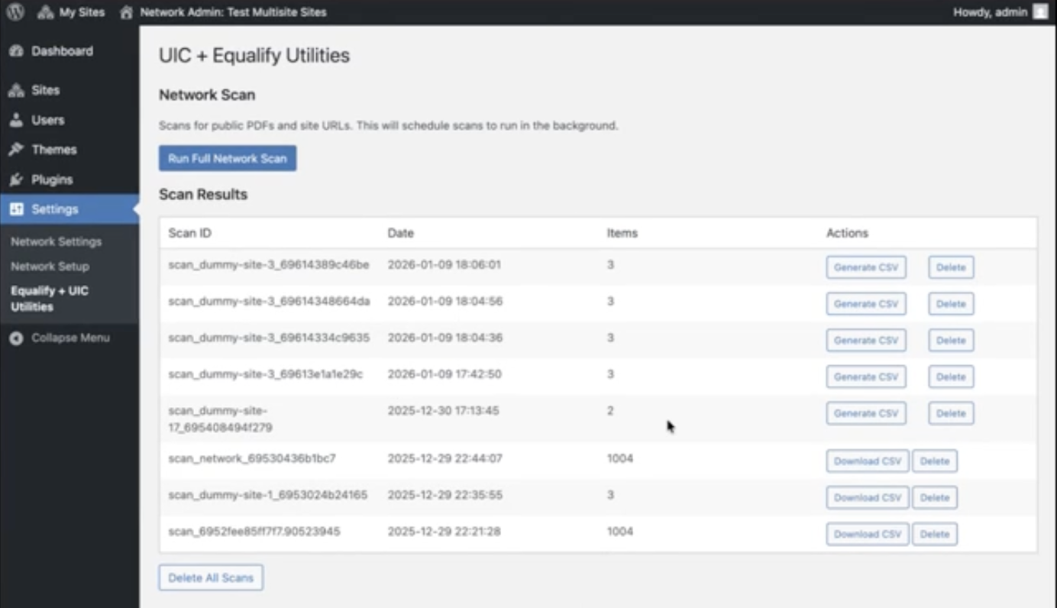 | UIC + Equalify Utilities with “Network Scan” header with button to run full network scan site scan and “Scan Results” header with a table containing Scan ID, Date, Items, and Action columns.
Sec 3_Audit Detail View Filtering and Search | 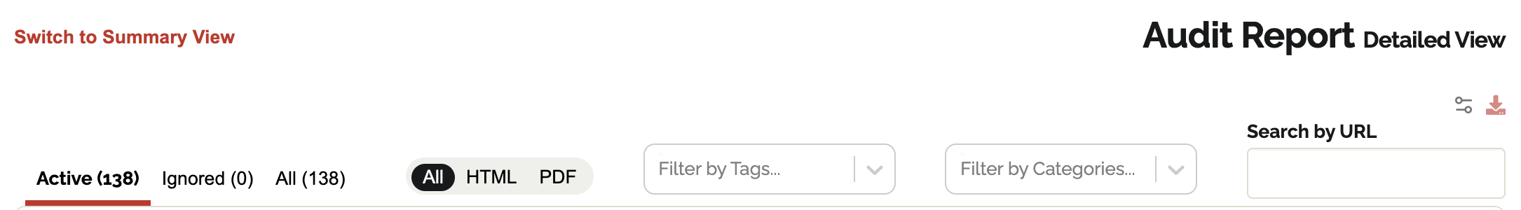 | Audit Report Detailed View header with Active/ Ignored / All tabs, and All / HTML / PDF filter buttons, Filter by Tags, Filter by Categories, and Search by URL field.
Sec 3_Dashboard Audit Report Detailed View | 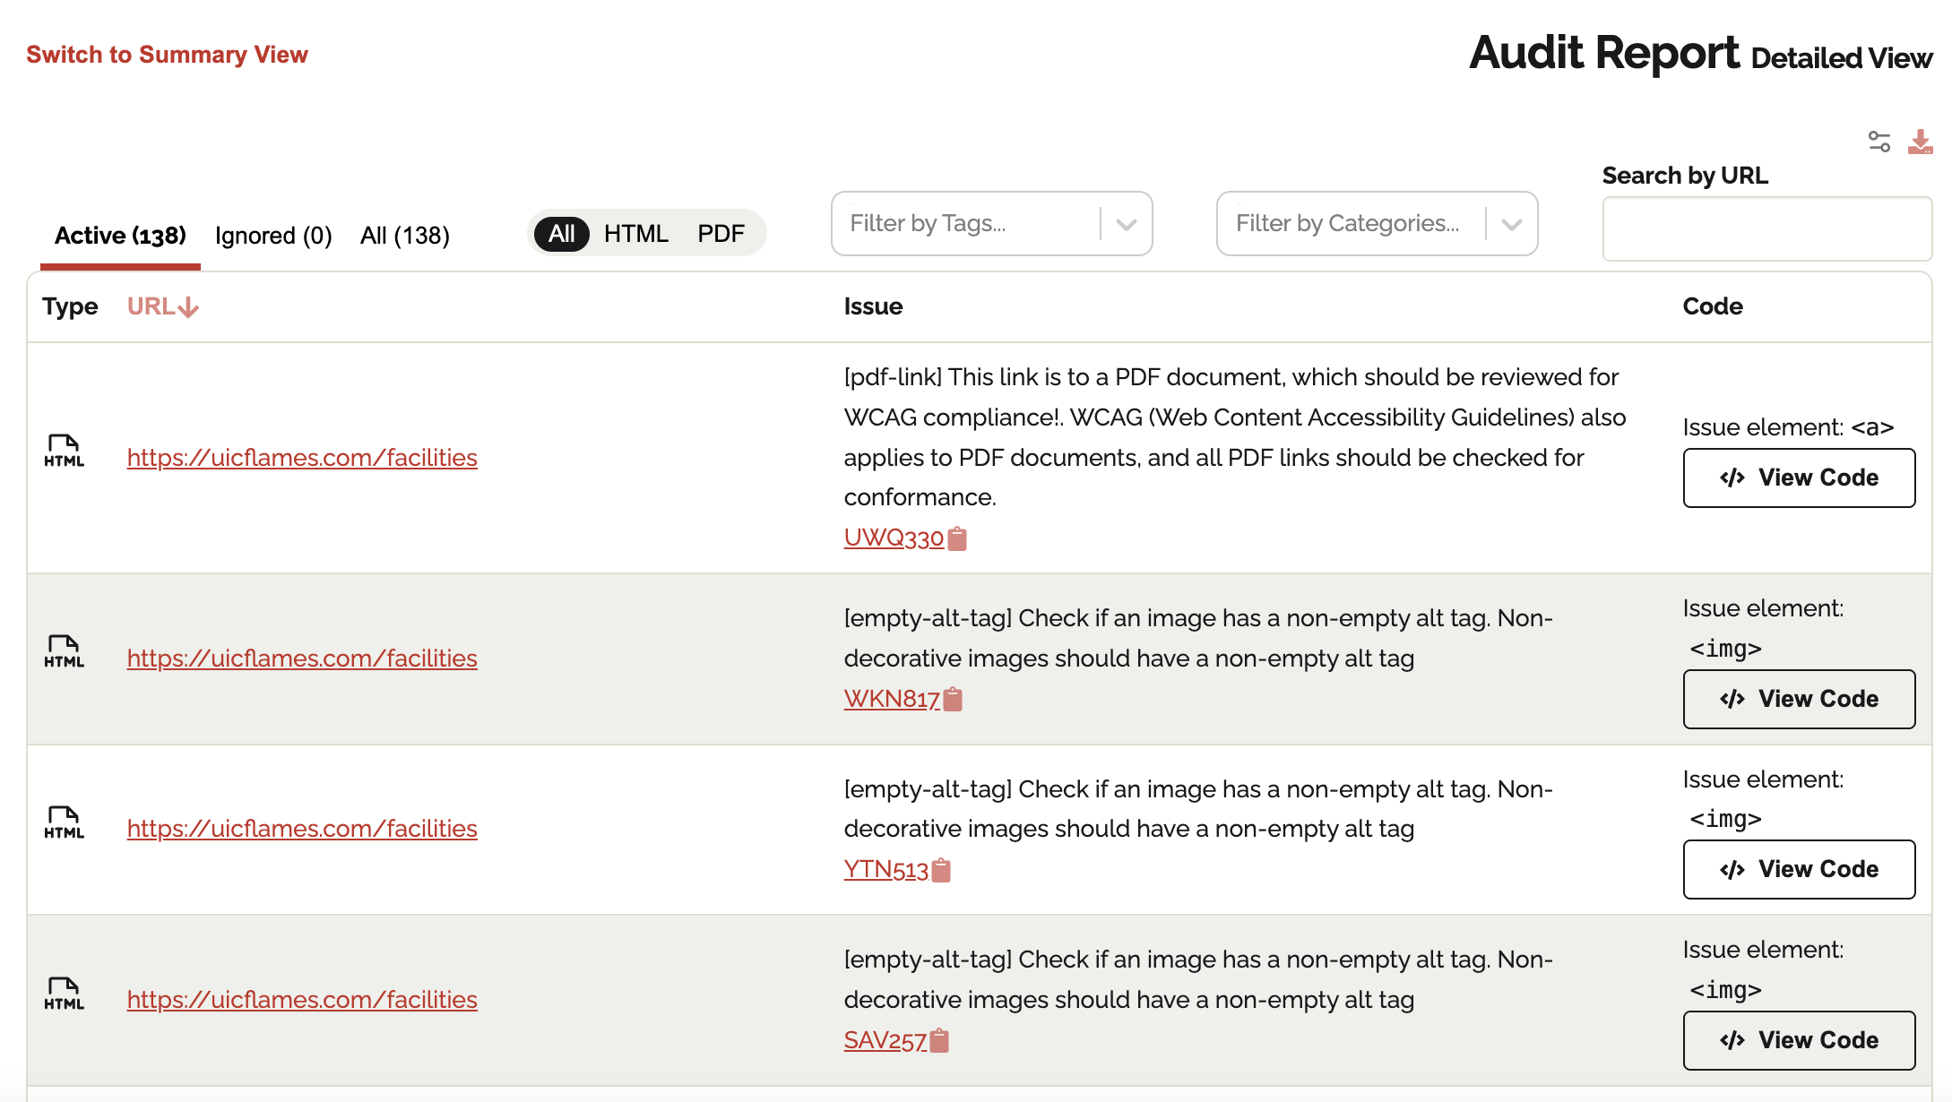 | Detailed audit results table listing Type, URL, Issue, and Code columns with View Code buttons for each issue.
Sec 3_Dashboard Audit Report Summary | 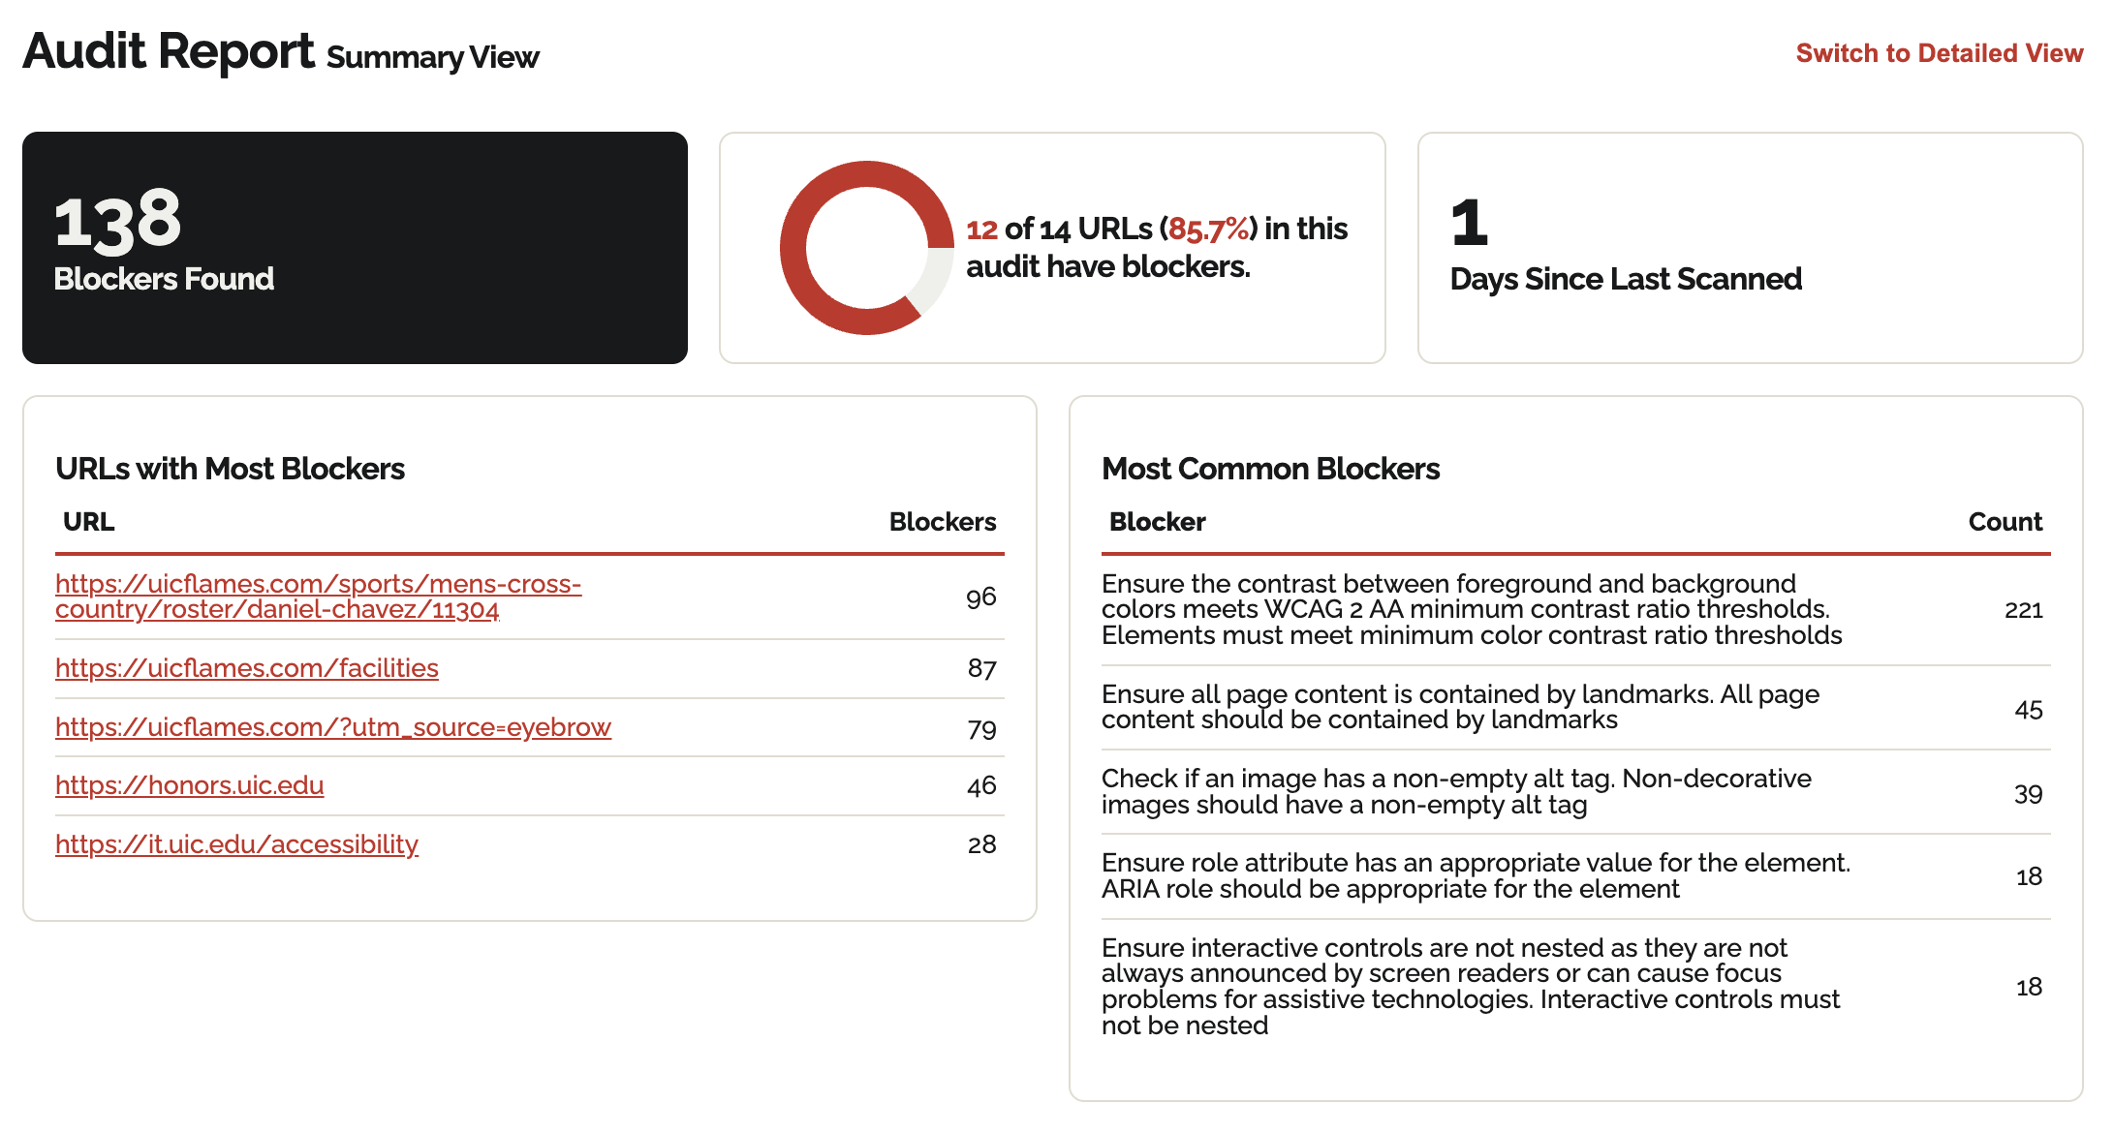 | Audit Report Summary View displaying 138 Blockers Found, a chart showing 12 of 14 URLs (85.7%) have blockers, 1 days since last scanned, and lists of URLs with Most Blockers and Most Common Blockers.
Sec 3_Dashboard Audit Title |  | Audit header showing Audit – Athletics – Facilities – All with edit and delete icons and buttons Scan Now and Share.
Sec 3_Dashboard Controls and Scheduling | 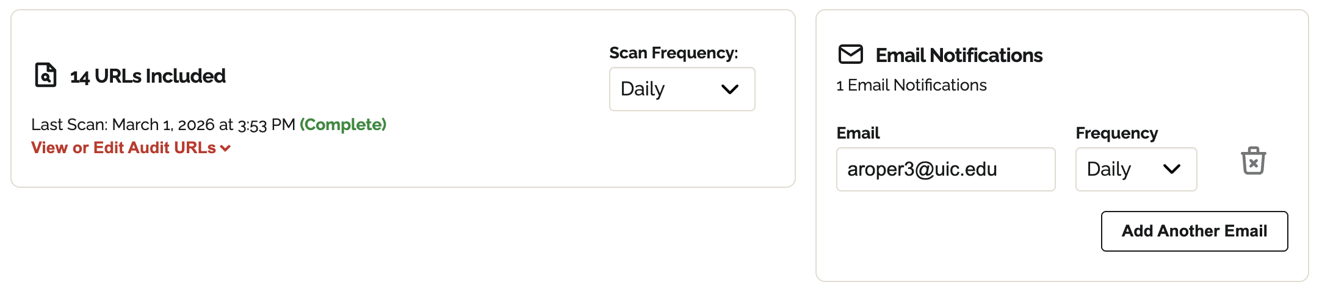 | Audit configuration panel showing 14 URLs Included, Scan Frequency: Daily, and Email Notifications section with Add Email Notification button.
Sec 3_Dashboard Performance Chart with Hover | 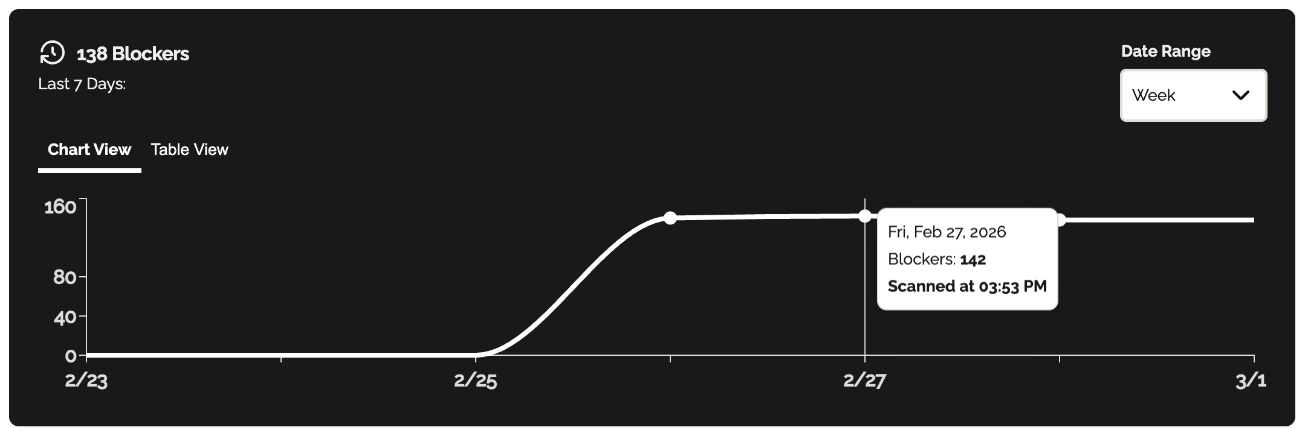 | Accessibility blockers trend chart labeled 138 Blockers – Last 7 Days with a tooltip displaying Fri, Feb 27, 2026 – Blockers: 142 – Scanned at 03:53 PM.
Sec 3_Dashboard Performance Chart | 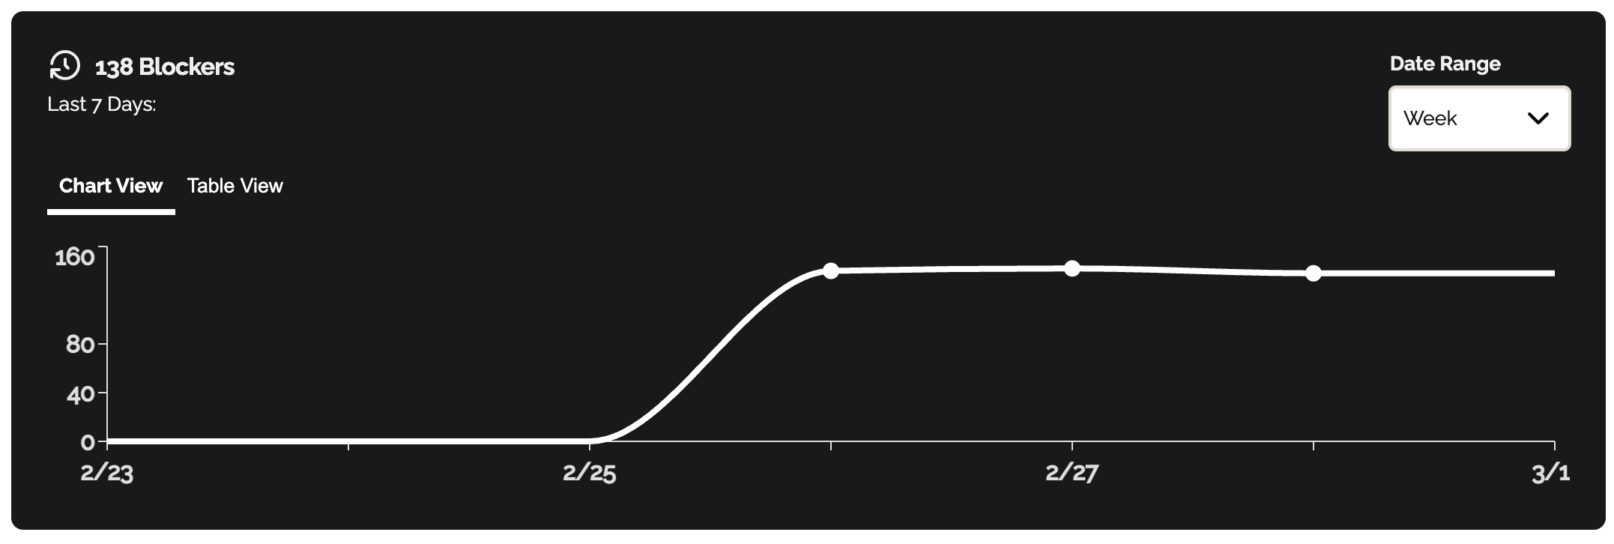 | Line chart showing blocker counts over time with Chart View / Table View toggle and Date Range dropdown set to Week.
Sec 3_Email notification | 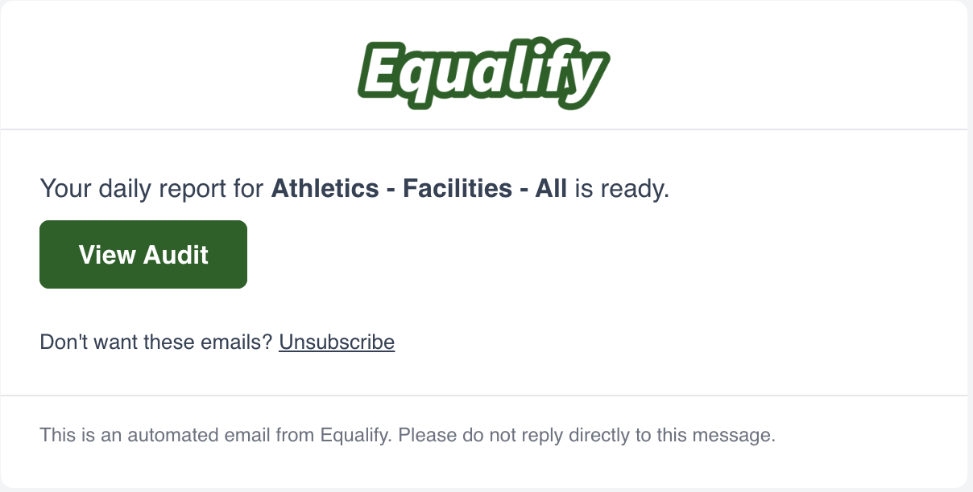 | Equalify email notification with "Your daily report for Athletics - Facilities - All is ready." with a green "View Audit" button.
Sec 3_Ignoring Blockers | 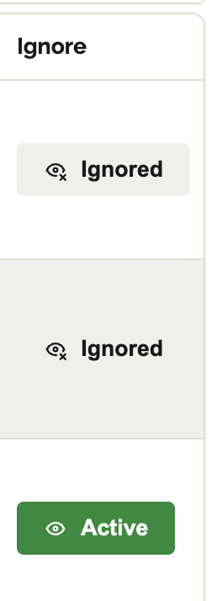 | Issue status controls showing Ignored labels with crossed-eye icons and a green Active button for toggling issue visibility.
Sec 3_Scan Errors Detail | 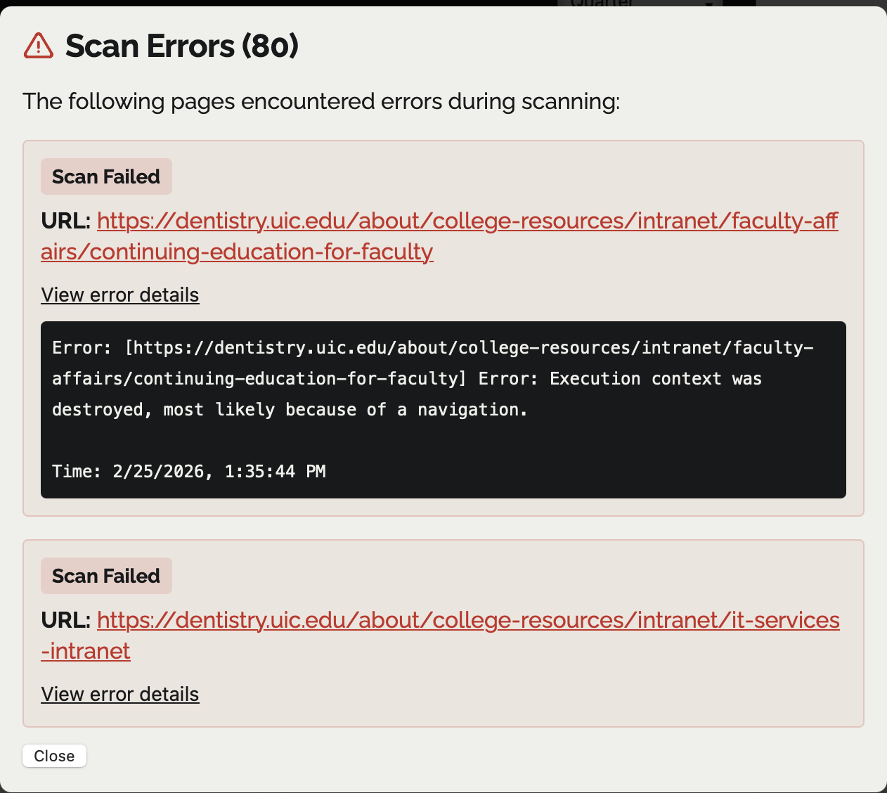 | Scan Errors modal with list of failed URLs. One entry shows a "Scan Failed" badge for a UIC dentistry intranet URL with a technical error message: "Execution context was destroyed, most likely because of a navigation."
Sec 3_Scan Errors | 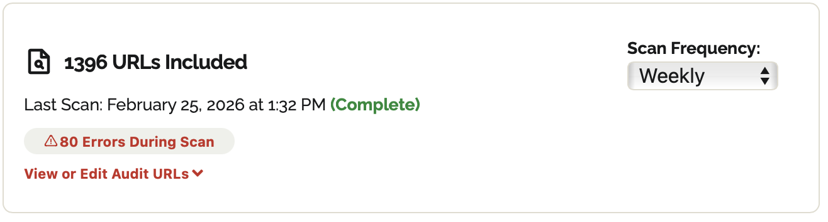 | A summary box for a website audit showing 1,396 URLs included. The last scan is marked as complete for February 25, 2026, and includes a red warning badge stating "80 Errors During Scan."
Sec 4_Logs Changes | 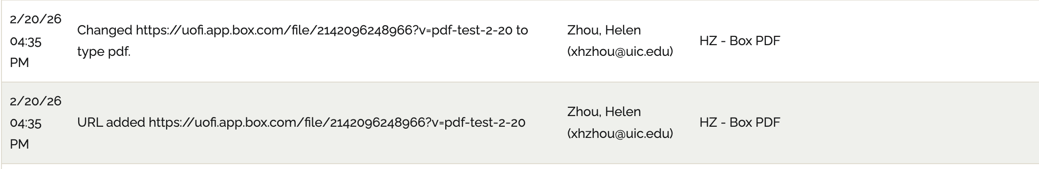 | Activity log entries listing date, time, message, user email, and audit name for actions such as URL type changes and URL additions.
Sec 4_Logs | 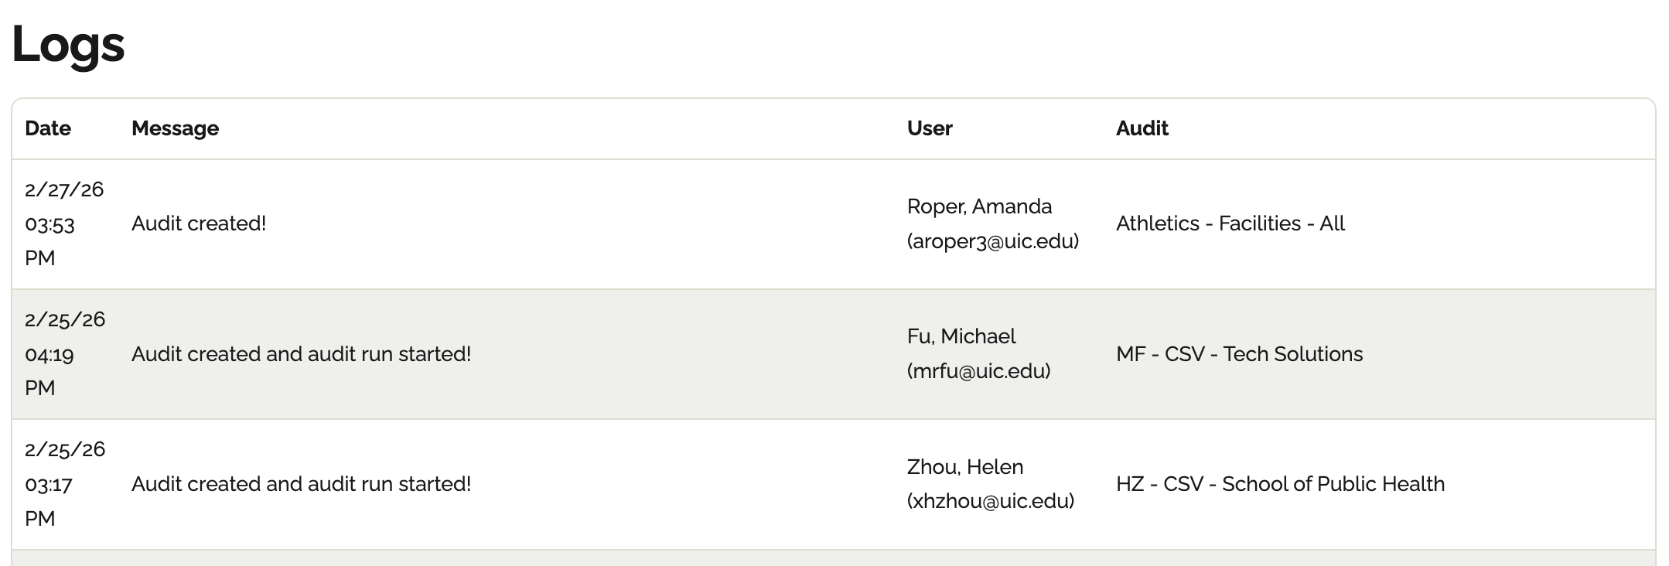 | Logs page displaying table columns Date, Message, User, and Audit, including entries such as “Audit created!”
Sec 5_Account Detail | 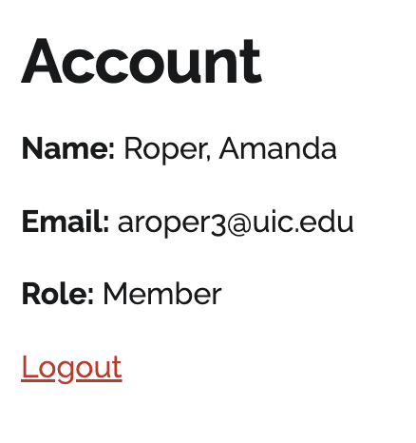 | Account page displaying Name: Roper, Amanda, Email: aroper3@uic.edu, Role: Member, and a Logout link.
Sec 5_Invite Deleted | 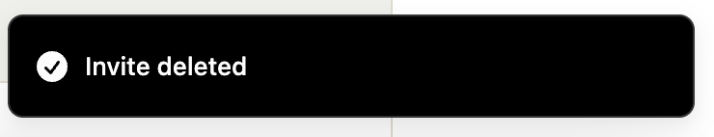 | Confirmation notification banner stating “Invite deleted.”
Sec 5_Invite Error Domain | 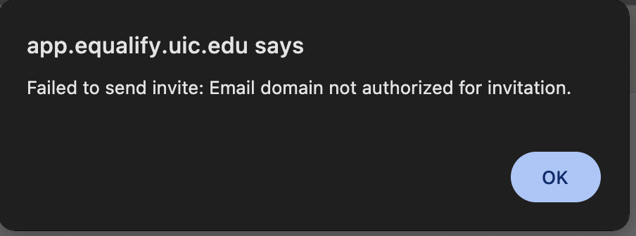 | Error pop up: app.equalify.uic.edu says: Failed to send invite. Email domain not authorized for invitation. “Ok” button.
Sec 5_Invite Error Duplicate Email | 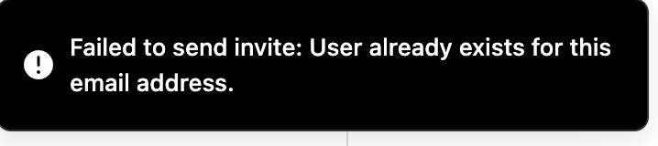 | Error notification banner stating: "Failed to send invite: User already exists for this email address."
Sec 5_Invite Sent | 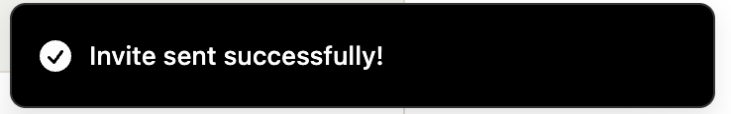 | Confirmation notification banner stating “Invite sent successfully!”
Sec 5_Invites | 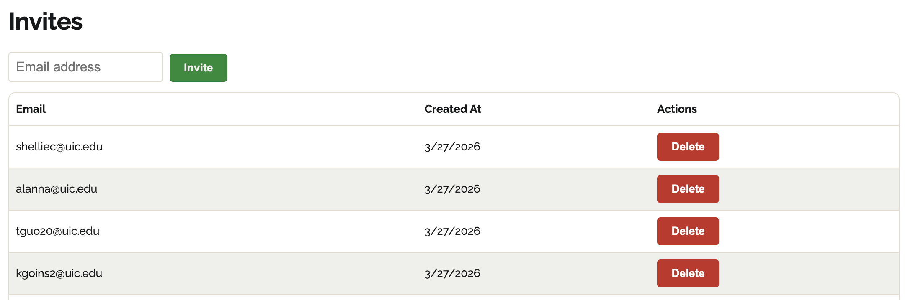 | Invites table displaying email addresses, dates added, and options to delete each entry.
Sec 5_Users Type Confirmation | 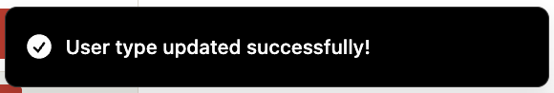 | Confirmation notification banner stating “User type updated successfully!”
Sec 5_Users Type Dropdown | 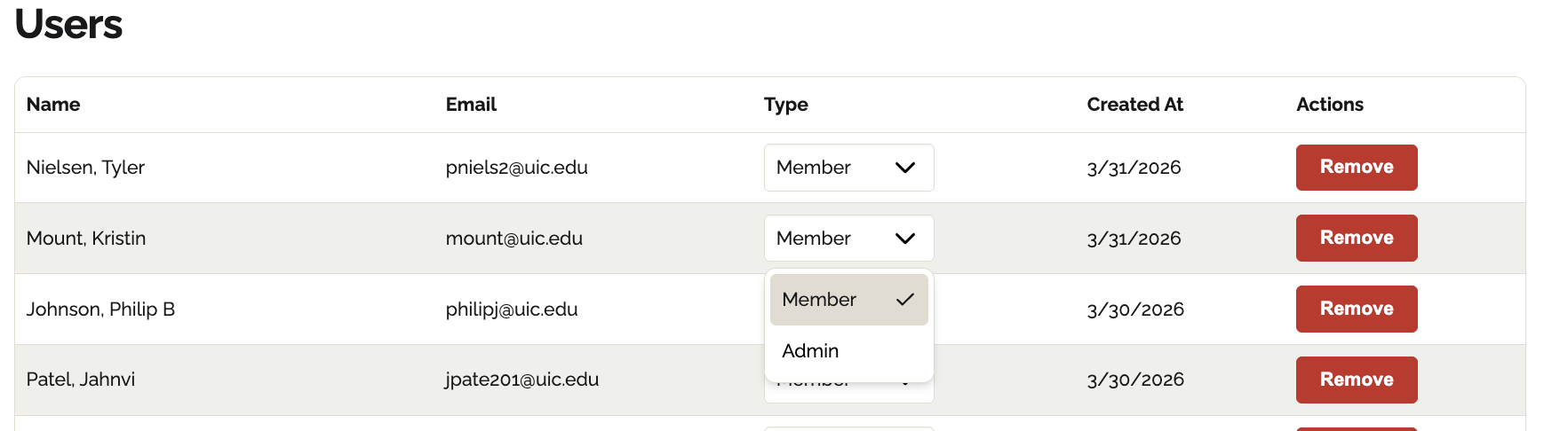 | Users table showing a "Type" dropdown menu with Member and Admin options selected for a user row.
Sec 5_Users | 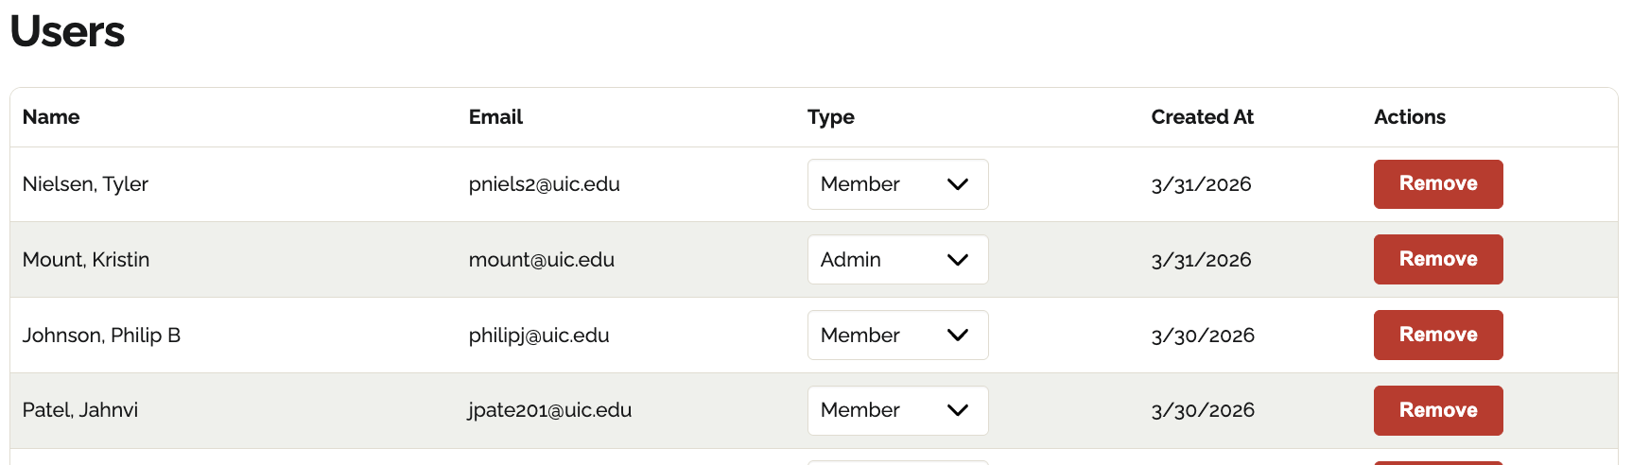 | Users table with columns for Name, Email, Type dropdown, Created At date, and a Remove action button for each entry.

